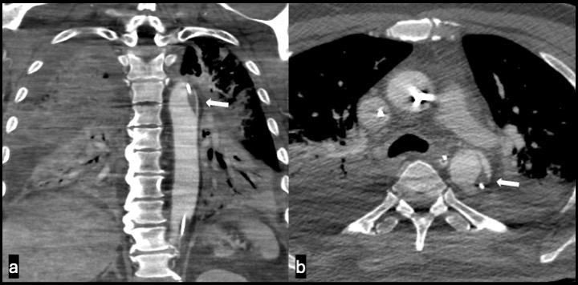

Figure S8. Thrombus formation along Impella catheter. (A) Coronal contrast CT view of thrombus formation along the catheter of the Impella device. (B) Axial view of the CT shows thrombus causing filling defect most prominently at the posterior wall of the descending aorta. Free floating thrombi is a concern.

