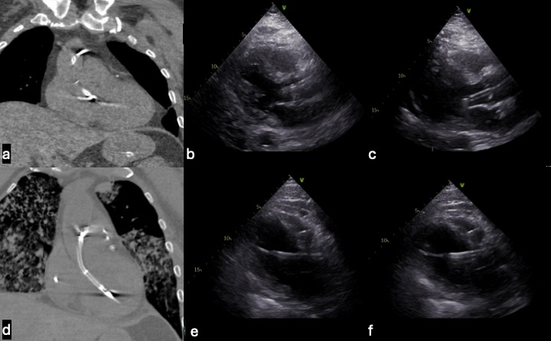

Figure S6 Impella Characterization on CT Chest with Associated Transthoracic Echocardiogram. Coronal CT Chest and associated Parasternal Long Axis (PLAX) view of patient echocardiograms exhibiting mispositioned Impella placements that required repositioning. (A) High Impella positioning with the Impella inlet being very proximal to the aortic valve plane. (B) The associated PLAX of the high Impella measuring 0 cm from the Impella inlet to the aortic valve plane. (C) Repositioning of the originally high Impella placement to 3.4 cm between the Impella Inflow to the aortic valve plane, representing an optimal position. The optimal distance between the Impella inlet and aortic valve plane should be 3.5 cm. (D) Low Impella positioning with the Impella inlet being distal to the aortic valve plance. (E) The associated PLAX of the low Impella measuring 4.6 cm from the Impella inlet to the aortic valve plane. (F) Repositioning of the originally low Impella placement to 3.7 cm between the Impella inlet to aortic valve plane, representing an optimal position.

