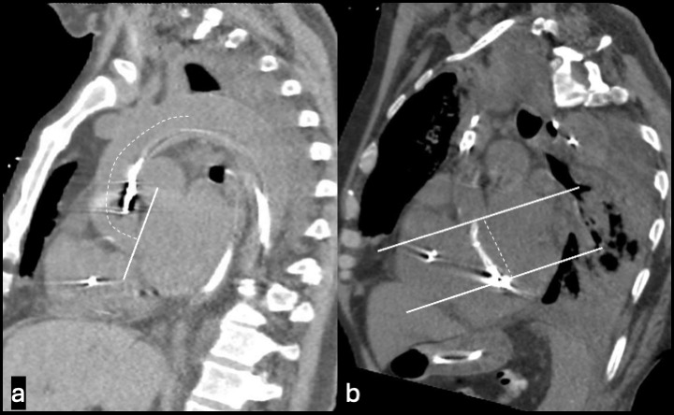

Figure S4. Central line, multiplanar reconstruction CT measurements. (A) Central line measurement that is made from multiplanar reconstruction showing the distance between the aortic valve plane and the top of the aortic arch with reference to the frontal scout of the CT. (B) Aortic valve plane to impella inlet port distance measurement that is made from multiplanar reconstruction.

