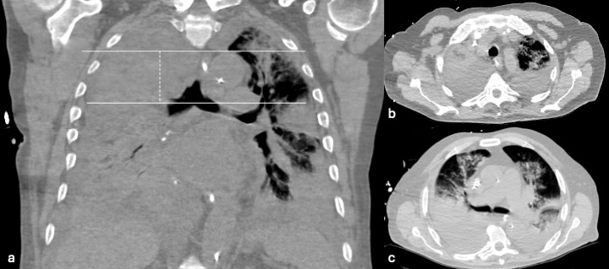

Figure S3. Aortic arch to carina measurement from CT. (A) Coronal CT image of Impella patient shown. Using Phillips Intellispace Portal version 8.0 software, correlations between the coronal view of the patients chest CT and 1 mm slices from corresponding axial CT images were made to calculate the distances from the patient’s aortic arch to aortic valve plane, aortic arch to carina, carina to aortic valve plane, and aortic valve plane to impella inlet. Specifically this image shows the coronal view of the carina and top of the aortic arch in one plane. (B) This image shows the corresponding axial CT at the level of the top of the aortic arch. (C) This image shows the corresponding axial CT at the level of the carina.

